Ionic Lock book

ionic run Commnd list

web run application commnad:- npx ionic serve

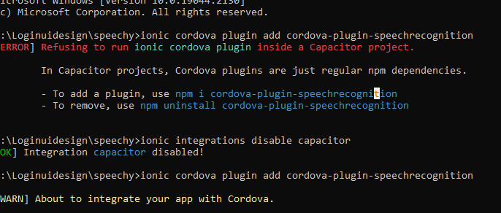

Solutions:- https://stackoverflow.com/questions/55057773/cordova-plugins-not-working-with-capacitor